Python Internship Tasks Report
Name: Niveditha
Course: B.Tech CSE
Domain: Python Development Internship
Task 4:
Flask Mini Project (Web Application)
Objective
To understand backend web development using Flask by building a simple web application with routing, form handling, and dynamic output.

Description
In this task, I developed a basic web application using Flask. The application allows users to enter their name through a form and displays a personalized greeting message.
The project demonstrates:
- Flask routing
- Handling GET and POST requests
- Form data processing
- Dynamic content rendering
This task helped me understand the fundamentals of backend development and how web applications work.
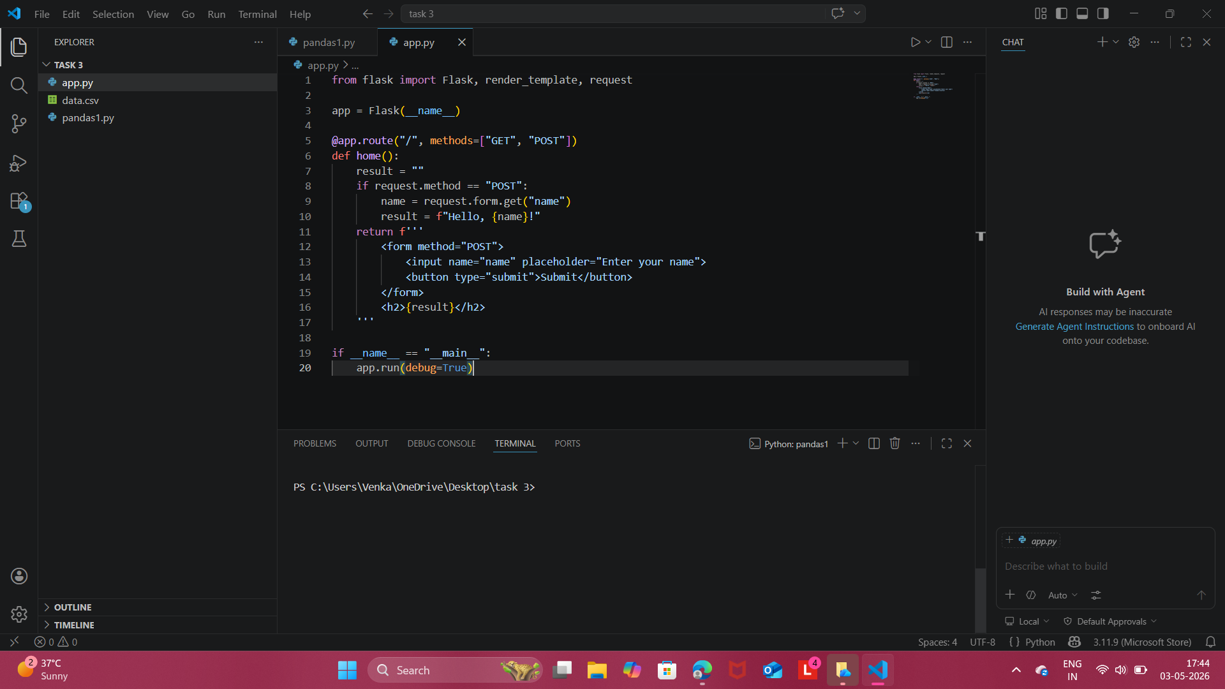
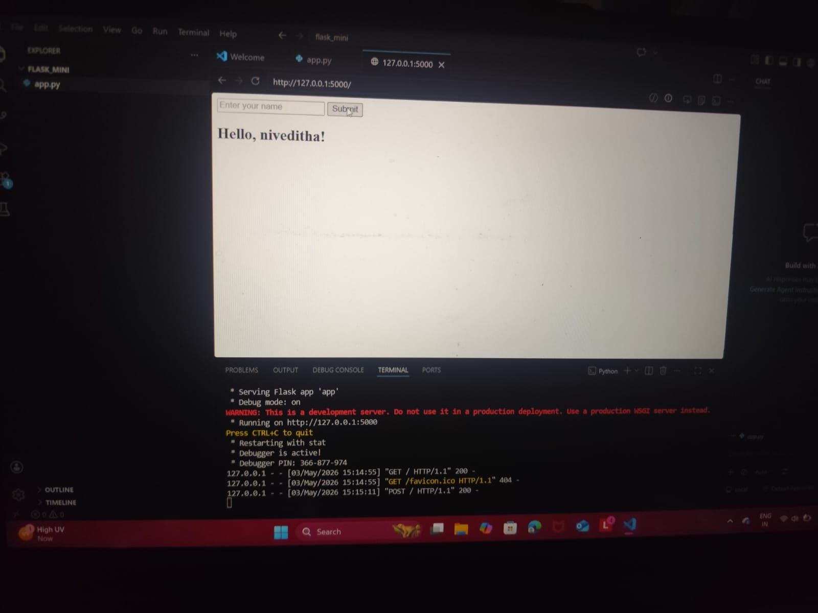
Output
- When the application runs, it opens in a browser at:
http://127.0.0.1:5000
- The user enters their name in the input field
- After clicking submit, the page displays:
"Hello, [Name]! Welcome to Flask App."

Conclusion
This task provided hands-on experience in building a simple web application using Flask. It helped me understand routing, form handling, and dynamic content generation. This project strengthened my understanding of backend development and web application flow.

